
Fort Duffield

Fort Duffield Park and Historic Site is a 175-acre resource in North Hardin County, Kentucky. Once part of the Fort Knox Installation, the land was given to the City of West Point in 1978 as part of the National Park Service Lands to Parks Program to be used for public recreation. The historic site, Kentucky's largest and best-preserved Civil War earthen fortification, sits within the park high atop historic Pearman Hill, 300 feet above the City of West Point. The fort is a Kentucky Landmark and on the Civil War Discovery Trail.

West Point and Fort Duffield played an important role during the American Civil War in the last quarter of 1861 and throughout 1862. Gen. William Tecumseh Sherman ordered fortifications built at the historic Mouth of Salt River at West Point for several reasons. Once the neutrality in Kentucky was broken, the training and movement of troops for the Union Army began with great urgency. It was crucial that the Union Army maintain control of the rivers and roads in the area so that troops and supplies could be moved. Supplies from Louisville were sent by steamboats on the Ohio River and then offloaded onto wagons at West Point. The wagons transported the much-needed supplies to training camps and troops further to the south.

Beginning in the fall of 1861, regiments from Indiana, Ohio, Wisconsin and Michigan stopped at West Point on their way south. At first, troops were ferried across the Salt River from Jefferson County into Hardin County at West Point. Once Army Engineers arrived, a pontoon bridge was installed. The 9th Michigan Volunteer Infantry is credited with the construction of the fort and before they left West Point, they also built a wooden bridge across the Salt River for supply and troop movements which was used to great advantage.

In the early spring of 1862, Brigades of Union troops were ordered to West Point to embark on steamboats down the Ohio River. Brig. Gen. William “Bull” Nelson, Kentucky native, left West Point with his 4th Division in February of 1862. In March of 1862, the 9th Michigan left with the 23rd Brigade under the command of their own Col. William W. Duffield.

President Lincoln felt he must have Kentucky to save the Union. Fort Duffield's strategic location above the confluence of the Salt and Ohio Rivers would control both rivers for the Union. Since the railroad did not run through West Point at the time of the Civil War, Gen. Sherman realized the importance of securing a land route for the movement of troops and supplies. A fort at West Point would insure control of the rivers and keep land and water routes open for the Union Army as well as protect Louisville from any attacking Confederate forces trying to use those same routes.
After the Battle of Perryville, Kentucky in the Fall of 1862, the war moved south. The artillery and munitions at Fort Duffield were ordered returned to Louisville in December of 1862 and the fort was left undisturbed except for an occasional guerrilla raid. This impregnable fortress, some 300 feet above the city of West Point, Kentucky, was never challenged. However, its strategic position no doubt played an important role in the Civil War in Kentucky.

Fort Duffield Heritage Committee
City of West Point, Kentucky

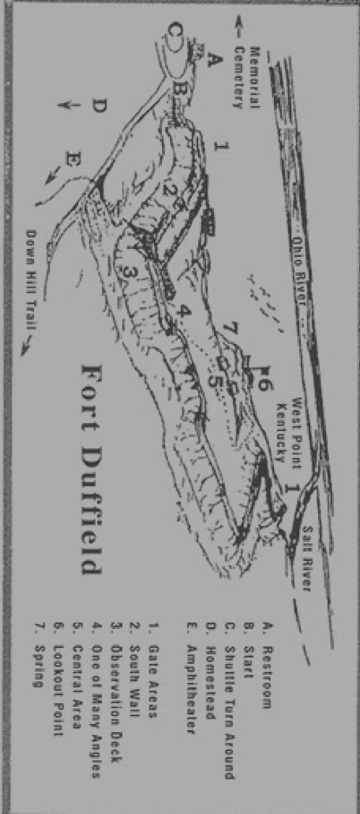

1. Gate access. (East and West ends of the Fort) 

Garrison Size and Guard Allocation

Fort Duffield is a Union American Civil War fort located outside West Point, Kentucky. In 1862, it garrisoned approximately 950 troops under Colonel William W. Duffield’s command, though most were soon sent to the front and the fort saw little action that year. For a gate access point, a fraction of the garrison—typically a 4 to 6-man detail—would handle security at any given time.

Standard Guard Detail Composition

a. Detail size: 4 to 6 soldiers under a corporal or sergeant
b. Duty pairing: two to three men posted, with the rest resting or managing paperwork
c. Watch shifts: two- to three-hour rotations, with at least two men paired after dusk

Physical Layout and Features

a. Sentry booth: simple log or board-and-frame lean-to, often reinforced with sandbags
b. Check station: a desk or barrel for reviewing passes, orders, and manifests
c. Armament display: rifles or muskets stacked upright beside the entrance
d. Lighting: a lantern or camp lamp hung overhead for evening inspections
e. Authority marker: nearby flagstaff hoisting the U.S. flag

Uniform and Equipment

a. Uniforms: blue frock coats or shell jackets, great coats in winter
b. Headgear: slouch hats or rain capes in inclement weather
c. Gear: cartridge boxes, bayonets fixed or ready, canteens on belts
d. Paperwork: passbooks, blank passes, and an officer’s orders book on the desk

The officers of Muldraugh Hill became very nervous though the rebel army was at Bowling Green and all of our army between so they erected the large gates at the two entrances to the Fort which were already well protected and then sent to the Colonel from massive locks to fasten them by night park cursed being in command directed the quartermaster to send them two toy padlocks less than the inch in diameter if the officers were delighted on receipt of the locks they did not laugh loud enough for us to hear them 24 miles away.

2. South East Wall

Coming up the sidewalk is Information on Fort Duffield, the Officers of Fort Duffield. General Sherman, whose Headquarters was in West Point. A photo of Abraham Lincoln. General William Tecumseh Sherman’s headquarters in West Point, Kentucky—not to be confused with the U.S. Military Academy at West Point, New York—was located in a historic home known as the Judge Fisher House, built in 1845. This site served as Sherman’s command post in 1861, during the early stages of the Civil War.

Sherman's Headquarters in West Point, KY

Location: Intersection of Elm Street and North 4th Street, West Point, Hardin County, Kentucky

Historical Significance: Used by Sherman while commanding Union troops in the region

Structure: A private residence built in 1845, now marked by a historical plaque

Marker Inscription: Notes Sherman’s use of the house as HQ and its Civil War relevance

This site is part of a cluster of Civil War-era landmarks in West Point, including the Ditto-Lansdale House (used as a hospital) and the Salt Warehouse, which supported Union logistics.

Abraham Lincoln

Abraham Lincoln was a towering figure in American history—both literally and symbolically. Standing at 6'4", he was the 16th President of the United States, serving from 1861 until his assassination in 1865, and is best known for leading the country through the Civil War and abolishing slavery through the Emancipation Proclamation and the 13th Amendment.

Civil War Leadership

Lincoln’s presidency was defined by the Civil War. He:

Preserved the Union against secessionist Confederate states.

Issued the Emancipation Proclamation in 1863, reframing the war as a fight against slavery.

Delivered the Gettysburg Address, a brief but powerful speech that redefined American ideals.

Promoted the Thirteenth Amendment, which abolished slavery in the U.S..

Assassination and Legacy

On April 14, 1865, Lincoln was shot by John Wilkes Booth at Ford’s Theatre and died the next morning1. His death shocked a nation already weary from war. He is remembered as one of the greatest U.S. presidents for his moral clarity, leadership, and empathy
General William Tecumseh
General William Tecumseh Sherman was one of the most formidable and controversial figures of the American Civil War. Known for his relentless strategy and psychological warfare, Sherman reshaped military doctrine and left a legacy that still sparks debate today.

Key Highlights of Sherman’s Life and Career

Early Life
- Born February 8, 1820, in Lancaster, Ohio
- Named after the Shawnee chief Tecumseh, reflecting his father’s admiration for Native American leadership
- Raised by Senator Thomas Ewing after his father’s death; later married Ewing’s daughter, Ellen

Military Career
- Graduated from West Point in 1840
- Served in the Second Seminole War, but missed combat in the Mexican-American War
- Resigned from the Army in 1853 to pursue banking and education, including a stint as superintendent of what is now Louisiana State University
Civil War Legacy
Sherman rejoined the Union Army in 1861 and quickly rose through the ranks:
Campaign | Description
Battle of Shiloh | Fought under Grant; wounded but proved his resilience
Vicksburg Campaign | Helped secure control of the Mississippi River
Atlanta Campaign | Captured Atlanta, a major Confederate stronghold
March to the Sea | Infamous scorched-earth march from Atlanta to Savannah, Georgia
Carolinas Campaign | Continued destruction through the Carolinas, hastening Confederate collapse
Sherman’s tactics—especially his “total war” philosophy—were designed to break the South’s will to fight by targeting infrastructure, industry, and civilian morale. Though effective, they earned him lasting resentment in the South.

Postwar Influence
- Served as Commanding General of the U.S. Army (1869–1883)
- Declined multiple offers to run for president, famously saying: “I will not accept if nominated and will not serve if elected.”
- Authored a widely read memoir that shaped public understanding of the war
Sherman died on February 14, 1891, in New York City and is buried in St. Louis, Missouri
Colonel William Ward Duffield

WILLIAM W. DUFFIELD
First Colonel of the Ninth Michigan Infantry

WHY HE WAS POPULAR

In a letter dated Dec. 16, 1861, Charles W Bennett wrote, "We had a bully regimental drill this afternoon and the colonel praised us highly for doing so well after being idle from drills so long because of so much sickness. We have a noble colonel. I have never heard him speak a cross word, and he is very kind to his men. Several times he has told the boys when' in line on parade, before all the officers, to report to him if their officers misused them. His greatest care is for our comfort.
The colonel of the Indiana regiment commander swears at his men when they make a mistake in drilling so he can be heard for half a mile. When we all get mixed up in drilling Colonel Duffield just indulges in a hearty laugh. Then he will say, 'Now, my lads, we will try it again.' He has threatened to file charges against the Indiana colonel for his abusive language to his men.

Colonel William Ward Duffield was a pivotal figure in Michigan’s Civil War history—engineer, soldier, and later superintendent of the U.S. Coast and Geodetic Survey.

Early Service: Duffield first served in the Mexican American War as adjutant of the 2nd Tennessee Infantry and later on General Gideon Pillow’s staff.

Civil War Role:

Initially joined the 4th Michigan Infantry as lieutenant colonel and fought at First Bull Run.

In October 1861, he became colonel of the 9th Michigan Infantry, leading its construction of Fort Duffield in West Point, Kentucky.

Appointed acting brigadier general in April 1862, though the Senate never confirmed the rank.

Served briefly as military governor of Kentucky in May 1862.

Battle of Murfreesboro (July 13, 1862):

Arrived with the 9th Michigan just before Confederate General Nathan Bedford Forrest attacked.

Duffield was wounded twice—once in the thigh and once in the groin—and captured during the battle.

He was released after a lengthy recovery and did not return to field command.

Postwar Life

After the war, Duffield managed coal mines in Pennsylvania, Michigan, and Kentucky, and worked as a railroad surveyor. In 1894, he was appointed Superintendent of the U.S. Coast and Geodetic Survey, serving until 1897.

He passed away in 1907 and is buried in Arlington National Cemetery, Section 3.

Colonel Charles Victor DeLand

Colonel Charles Victor DeLand was a distinguished Michigan officer whose Civil War service spanned multiple regiments and battlefronts. His legacy is tied to both the 9th Michigan Volunteer Infantry and the 1st Michigan Sharpshooters, where he earned a reputation for bravery, resilience, and leadership.

Military Service Overview

Early Role: DeLand began his service by organizing Company C of the 9th Michigan Infantry in 1861. He was commissioned as Captain and served through late 1862.

Battle of Murfreesboro (July 13, 1862): He was wounded and captured during the Confederate raid led by General Nathan Bedford Forrest. DeLand spent five months in captivity before being exchanged.

Promotion and Sharpshooter Command: In 1863, DeLand was promoted to Colonel and placed in command of the newly formed 1st Michigan Sharpshooters, a regiment known for its elite marksmanship and diverse composition—including Native American soldiers in Company K.

Major Engagements:

Spotsylvania Court House (wounded, May 12, 1864)

Battle of the Crater (July 30, 1864)

Fort Pegram / Poplar Springs Church (wounded and captured again, September 30, 1864)

Final Rank: On March 13, 1865, he was brevetted Brigadier General of U.S. Volunteers for “faithful and meritorious services during the war”.

Postwar Contributions

After the war, DeLand returned to Michigan and became a newspaper editor in Saginaw. He also compiled the History of Jackson County in 1903, which remains a respected local reference. He passed away in Jackson, Michigan, on September 21, 1903, and is buried at Mount Evergreen Cemetery

3. Observation Deck


Southern Redoubt and Replica Homestead
As you look south, you’ll notice a shallow depression in the earth—this is the fort’s redoubt. A redoubt is a small, detached defensive earthwork, placed forward of the main walls to give soldiers a clear field of fire and an early warning of any advancing enemy. Now it is being used as an amphitheater.

Adjacent to the redoubt stands a replica homestead, modeled after the simple log cabins common in mid-19th-century Kentucky. These homesteads dotted the Bluegrass countryside, and their open yards would have provided Confederate scouts with cover during a southern approach.

The 9th Michigan Infantry focused much of their attention on this southern sector, knowing that any assault would likely come across these farms and fields. To the north, the 300-foot-high cliff—an imposing barrier kept attackers at bay and cover the fort’s front approach. The front of the Fort overlooks the Ohio River.

Battle of the pickax

Remember the average age of Soldiers during the Civil War was 18. These young men have never been to war and were afraid of everything in the shadows. Along this south wall while the soldiers were performing picket duty one noticed what looked like a rifle and glowing eyes looking up at them. Immediately pursued a battle.

During our first weeks at West Point night alarms were frequent Tuesday night November 12th the four regiments of infantry and one of Calvary were rallied to arms 4 times. First a Sentinel saw a pick sticking in the top of a stump and imagined it was a rebel aiming his gun and he blazed away, of course the other guards fired their guns in the air and then all the drummers tried to see which could beat his drum the hardest companies E and G were then alone on the hill and expected to be the first ones gobbled up; but reinforcements came up to us on the double quick. This performance was repeated 3 times before morning caused by other nervous Sentinels “seeing something”. The absurdity of it was that no rebels were nearer than Bowling Green, 50 miles away and our army was between us, but we were all “raw” then and imagined there was a rebel behind every Bush, tree and knob and several luckless pigs lost their lives by being too inquisitive after dark.

4. Cannon Positions

a. Fort Duffield is a thousand-foot-long earthen wall with ten angles of fire. The most common gun (cannon) used was the 6-pound smooth bore. At least one gun was positioned behind each of the ten angles of the fort wall for all around covering fire in the direction of many back roads to the south of the fort.

b. According to a letter by Capt. Charles V. DeLand, the distance from the top of the wall to the bottom of the ditch was
17 ft. The top of the wall was 9 ft. wide. Time has eroded the walls to today's present height and thickness.

c. Civil War fortifications were precisely designed. Every angle, mound of earth, and slope you see at Fort
Duffield had a specific purpose. The ten angles of the fort were designed to allow infantry and artillery to sweep every inch of ground in front of the fort. There were no "dead spaces” where an attacking foe could take refuge. As Captain DeLand wrote, "every gun in the fort will sweep the turnpikes and rivers with shot and shell for three miles."

d. Fort Duffield was not shaped like most forts of the time which were octagon or star shaped. The wall was shaped somewhat like the letter "W" and open on the back side (facing the town of West Point) because of the 300-foot sheer cliff at the rear of the fort.

e. Although the 9th Michigan was an infantry unit, they manned their own guns until they were relieved by units
from the First Michigan Artillery.

f. A large timbered gate was located at both ends of the thousand-foot-long earthen wall. Both gate areas
hugged the cliff so as to allow maximum protection for the defenders. The fort was so secure that when the request was made for locks for the gates, the quartermaster sent two toy locks as a joke.

g. Captain Charles Victor DeLand, Commander of Co. C, 9th Michigan Infantry, stated in a letter home that they felt "as secure as a nest of young eagles in our new fort."

h. Captain DeLand of the 9th Michigan wrote on December 5th, 1861, "Our new camp upon the mountain is a paradise to what we have enjoyed for the past four weeks, and pure air and water are showing their invigorating effects upon the men daily, almost hourly."

The fort was fifteen rods deep, and about forty rods in a straight line from right to left; but it was about eighty rods to follow all the angles, with a wide, deep ditch all around it, and would mount ten cannons and 1,000 men. A corn field occupied the top of the hill when we took possession, but all around that were large trees which were cut down to give free range to the guns.

5. Central area


From the Central area and we look down the berm, it is somewhat hard to really see what it would have looked back when the 9th MI started to build the fort. Click code for picture.
Possible site of test firing of the Stuckey Gun.

Crossing the world in late 1861, Steven Stuckey of New Albany, Indiana invented a “Rifled” cannon which proved to be more accurate than anything in use by the union army. Stuckey owned the American Foundry Co.The cannon was first Test fired in New Albany, and the gun had a mishap where the ring snapped. Wharf Master Raynor volunteered to repair the gun, the Stuckey gun was then brought to Fort Duffield where it was successfully fired.

The Ninth Michigan Infantry was assembled at Fort Wayne, Detroit, during the month of September 1861, and its 913 Were mustered into the US service October 15th. October 17 at dress parade time three men who had refused to be sworn into service for dishonorably drummed out of camp. On October 23rd Reverend Doctor George Duffield, the Colonel's father in an eloquent and patriotic address presented the regiment with a beautiful silk banner.
The 9th was the first Michigan regiment ordered to the western army and it left Fort Wayne on the ferry boat “Union” at 9:00 AM Friday October 25th, 1861, going 3 miles up the river to the landing near the Michigan central depot. After a considerable handshaking in the city left for the South on a Michigan central train drawn by two locomotives the head one nicely decorated and having a large band of reading death to traders went via Michigan City and Indianapolis stopped at Jackson for company C to bid goodbye to friends. At Marshall, the “Fusiliers” afterwards called Michigan engineers, and mechanics greeted us 800 strong and at Niles the citizens brought in coffee crackers and biscuits. When it was daylight our journey through the two states was almost an ovation that people cheering us along the way we arrived at Jeffersonville at 7:00 PM Saturday and remained in the cars until Sunday morning when we went up the Ohio River about two miles. in pitched tents on a table land about 20 feet above the river. That day we received our first guns, Belgian muskets caliber 69 that would kill before and cripple behind. General Sherman was then in command of the Army of the Ohio, and he called on the officers and gave orders for the regiment to go to West Point KY.
We got breakfast and struck tents before daylight on Monday morning October 28th and at 8:00 started down the river on 2 boats for West Point, a small village situated at the junction of the celebrated Salt River and Ohio 20 miles below Louisville where we arrived at 4:00 PM and camped on a flat on the east side of Salt River in an Old Orchard. The ground was wet, we did not know then how to make bunks of straw or rails, and it was the most fatal camp we ever had before. We buried 61 men on the hill near there within a few weeks. Several other regiments soon joined us here Colonel hazard of the 37th Indiana commanding the post across Salt River on its West side is the northern end of Muldraugh’s Hill about 300 feet high here and quite steep on the Riverside on Sunday November 3rd Charles Bennett had charge of 50 men under Lieutenant Wright as engineering officer and we graded a winding path up the side of the hill wide enough for two to walk abreast. Bennett remembers that very distinctively because it was the first time he ever worked on a Sunday, and it worried him very much. That was the beginning of the work of fortifying that hill on which the engineers estimated 70,000 days of work was expended the 9th during a large part of it making it quite a strong fortification Bennetts company G and company E were specially assigned to man the Fort with its two pieces of artillery (which were soon to be increased to 10) and we moved inside of the Fort and began about December 1st erecting log cabins. The other companies moved onto the hill November 18th and in December began building log cabins outside the Fort the fortifications and cabins were completed January 1st, and we expected to occupy them all Winter, but all our pleasant dreams of comfort were shattered 4 days afterward.
Thursday November 21 Colonel Duffield was made commander of West Point which was then an important base of supplies for our army concentrating at Elizabethtown and further South the supplies were brought here by steamers and then sent to the army South by wagons. The hill was fortified to protect the space of supplies and to fall back to in case of defeat.

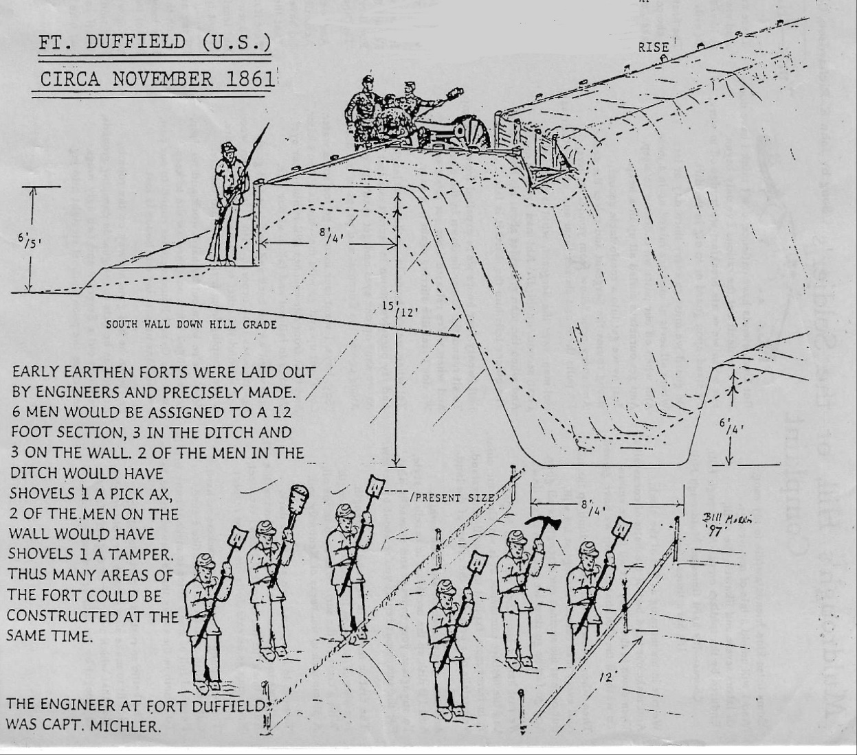

6. Lookout Point

Strategic Sentinel of the Salt River Valley – 1861–1862

Perched atop the steep escarpment of Muldraugh Hill, this natural vantage point offered Union forces a commanding view over the Salt River and Ohio River valleys. In late 1861, General William Tecumseh Sherman ordered the construction of Fort Duffield just below this ridge to protect vital Union supply lines.

From this elevation, Union troops monitored troop movements, guarded steamboat landings, and secured wagon routes delivering supplies from Louisville to southern training camps. The 9th Michigan Infantry, under Colonel William W. Duffield, built the fort and bridges that made West Point a logistical lifeline.

Though never attacked directly, Fort Duffield and the lookout above it played a quiet but crucial role in preserving Union control of Kentucky—an essential goal of President Lincoln, who famously said, “I hope to have God on my side, but I must have Kentucky.”

The lookout point at Muldraugh Hill near West Point, Kentucky offers one of the most striking natural vantage points in the region. This area is part of the Muldraugh Hill escarpment, a dramatic geological formation that separates the Bluegrass region from the Pennyrile Plateau. The steep climb from West Point up to the town of Muldraugh along U.S. Route 31W (Dixie Highway) showcases the elevation change—rising nearly 350 feet in just a few miles.

This area is known as Lovers Leap by the locals. When the Fort was being built all the trees were down for a mile around. The wood was harvested for lumber by the Soldiers and fuel for the Steamboats.

What Makes the Lookout Special

Panoramic Views: From the top of Muldraugh Hill, you can see sweeping views of the Salt River valley, Fort Knox woodlands, and the Ohio River basin on clear days.

Historical Significance: The ridge was strategically important during the Civil War and remains close to Fort Duffield, a Union fort built to protect the Louisville & Nashville Railroad and supply lines.

Scenic Drive: The ascent up the hill is especially beautiful in autumn, with vibrant foliage, or in spring, when redbuds and dogwoods bloom

7. Spring


Fort Duffield Spring
“Cut from Stone, Carved by Resolve”

In the winter of 1861–1862, Union soldiers of the 9th Michigan Infantry carved this spring into the hillside north of Fort Duffield. Using hand tools and black powder, they blasted through limestone to create a reliable source of fresh water—essential for survival atop Muldraugh Hill.

🔹 Soldier-Crafted Engineering Drill marks and a hand-cut channel remain visible today, guiding overflow from one basin to another. These features reflect the ingenuity and grit of men who built not just a fort, but a lifeline.

🔹 A Quiet Testament Though no longer part of the public trail due to safety concerns, the spring endures as a symbol of endurance and foresight. It was never just water—it was hope in stone.“We built high above the river, but it was the spring that kept us alive.” — Attributed to a soldier of the 9th Michigan Infantry

8. Keeping Warm


It was said that the Soldiers found a unique way of keeping warm. Col Hazard, Commander of the 37th IN, ordered that his men were not permitted to buy straw for their beds from the civilians. He ordered that only Government rations would be consumed. The weather in November thru December was very cold and wet and many died.
Here is an example of what the Soldiers may have used here at Fort Duffield. Also known as a Crimean oven. A fire was built out in front of the structure and the heat would flow through a tunnel inside the tent warming the floor, creating radiant heat, and the smoke would come out the back. The purpose of the water barrel on the chimney was to put out any fire caused by negligence or accident.

Walking Tour
The Fort from across the River

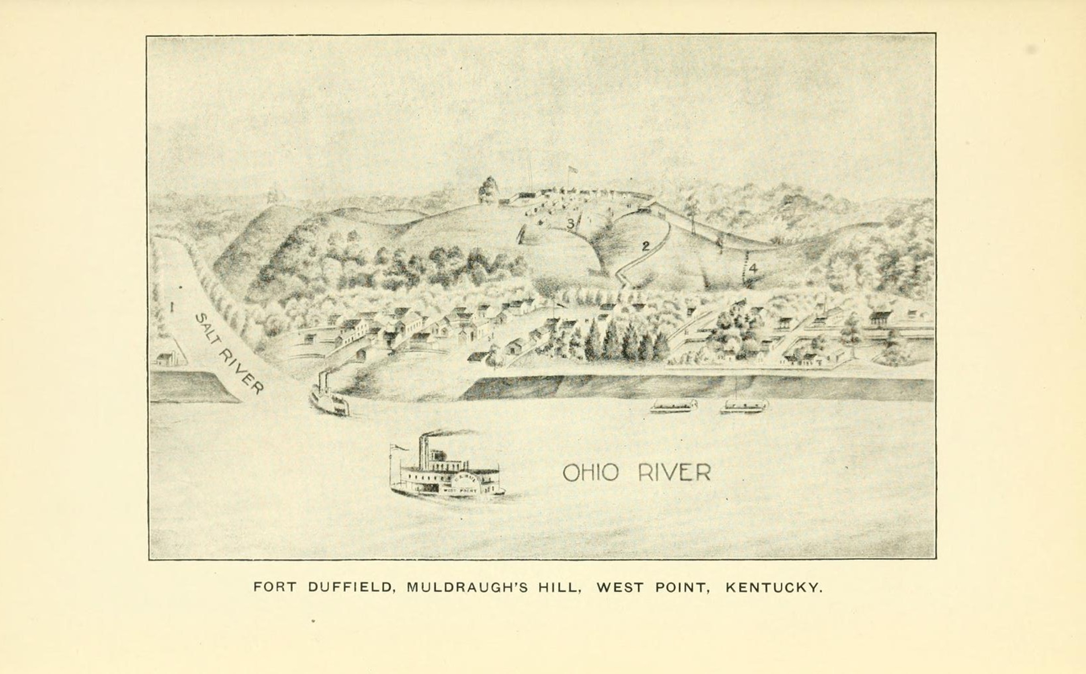

The Fort from across the River, Colonel Hazard 37th IN were stationed there.
Mostly built by the 9th Michigan Infantry in Nov. and Dec, 1861 From sketch by Charles A. Kelley, Co. I.

The Ninth first camped to the left of figure 1 and laid a bridge on scows there to cross Salt River. Fig. 2 is the upper half of the winding path, which ran as much further to the left behind the trees to the bottom of the hill. Fig. 3 marks steps to a spring, and Fig. 4 is a short route to town. Both of those places were as steep as ordinary stairs, but steps were made in the clay by constant use.
Teams got onto the hill by a long, winding road on the south side. Sixty-one men of the Ninth were hurried on the point of the hill just to the right of the picture.This view was taken from the hills the north, and shows only the top of across the river in Indiana a mile to Muldraugh's Hill, the lower part be ing hidden by the trees. There were several large fields in which the various regiments used to drill between the village and the hill, not shown. You are looking into the rear of the fort which faces from you to the south, and commanded the great Louisville and Nashville Pike, which passes around the hill to the right and rear. The fort was fifteen rods deep, and about forty rods in a straight line from right to left; but it was about eighty rods to follow all the angles, with a wide, deep ditch all around it, and would mount ten cannons and 1,000 men. A corn field occupied the top of the hill when we took possession, but all aroimd that were large trees which were cut down to give free range to the guns.
The Ninth first camped to the left of figure 1, and laid a bridge on scows there to cross Salt River. Fig. 2 is the upper half of the winding path, which ran as much further to the left behind the trees to the bottom of the hill. Fig. 3 marks steps to a spring, and Fig. 4 is a short route to town. Both of those places were as steep as ordinary stairs, but steps were made in the clay by constant use. Teams got onto the hill by a long, winding road on the south side. Sixty-one men of the Ninth were hurried on the point of the hill just to the right of the picture.

#FortDuffield #CivilWarHistory #HiddenLegacy #UnionSoldiers #HistoricalPreservation #SpringOfHope #KentuckyHistory #9thMichiganInfantry

